**Zork Wiki – Adam Atkinson**

1. The game is based off of an adventure through Scotiabank Arena right before the Raptors play in their NBA Finals game. You start where many fans all across the city come together, Jurassic Park. Making your way through the arena, your goal is to obtain the NBA Finals Trophy, which at that point you win the game.
2. 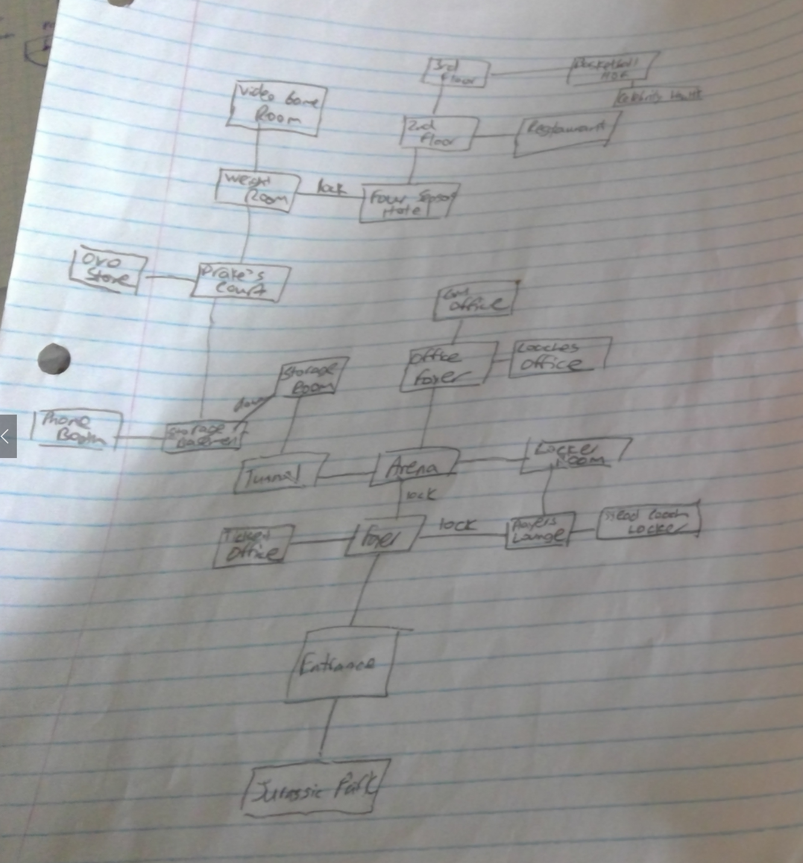
3. There are only a few classes to our game. In our rooms.dat file, we kept the rooms, room descriptions, and items in each room. Our Zork class is just the default class where you play the game. The Command class we mainly used for it’s second word methods, to see if what the player typed made sense. Our CommandWords class mainly was used to identify our 20+ commands that we were going to use in our game. Using those words, we created a method for each in the game class, as well as setting max inventory, adding items, and removing items. Our room class gives the ability to move the 6 directions. We also used the method longDescription() a lot as every time a puzzle is solved, we give them the updated description.
4. I learned a lot while doing Zork. Most of it came through the testing process. Mainly with the puzzles, sometimes we couldn’t access the appropriate room when we solved a puzzle, so I had to recognize that the rooms.dat file had the wrong name for the Storage; we called it “Storage Room” in one place and “Storage” in the other. Designing a game that wasn’t too difficult but gave a challenge to the player was also fairly challenging. We came up with the room structure first, and then came up with the puzzles and challenges after that. In total we have four “guarded rooms”, with 3 puzzles or keys. I also realized that for most of the game methods, the code was very similar, but I had to change the if condition for it to make sense in the appropriate method.
5. The testing was simply running through the rooms and playing the game as if I was a regular player. The main issue is the limited commands and synonyms, but the game makes sense with the main command words used in the regular Zork game we played in class earlier.
6. Our game doesn’t have many special features, except the puzzles, there is a secret 4 digit code used to get into the players lounge, and a secret code to get into the Hotel found by reading a paper from drake’s court.